Lab Manual



Course: BI-402

Bioinformatics Software Development

Term: Fall 2020, Class: BSBI-2017

Submitted By:

SYEDA ANUSH FATIMA 2017-BI-004

(Name) (Roll. No.)

Submitted To:

**Ms. Mehwish Mehmood**

**Department Of Bioinformatics**

**Sir Syed University Of Engineering and Technology**

**University Road Karachi - 75300**

<http://www.ssuet.edu.pk>

Table of content

|  |  |  |  |  |
| --- | --- | --- | --- | --- |
| S.no | Lab No | Task | Sig. | Remarks |
| 1 | 1 | **Creating Gantt Chart & PERT Chart Using MS Project** |  |  |
| 2 | 2 | **Introduction to UML (Unified Modeling Language) Diagram and Modeling use case diagram using visual paradigm** |  |  |
| 3 | 3 | **Creating Sequence Diagram using Visual Paradigm Software** |  |  |
| 4 | 4 | **Web Development Framework Using**  **“Dreamweaver CS 5”** |  |  |
| 5 | 5 | **Introduction to CSS** |  |  |
|  |  |  |  |  |
|  |  |  |  |  |
|  |  |  |  |  |
|  |  |  |  |  |
|  |  |  |  |  |
|  |  |  |  |  |
|  |  |  |  |  |

**Lab 5**

**Introduction to CSS**

**Exercise:**

1. Create and test an HTML document that describes nested ordered list of cars. The outer list must have three entries: compact , midsize, and sports. Inside each of these three lists there must be two sublists. The compact and midsize-car subtitles are two door and four door; the sports-car are coupe and convertible. Each body style sublist must have at least three entries, each of which is the make and model of a particular car that fits the category. The outer list must use uppercase Roman numerals, the middle list must use upper case letters, and their inner list must use Arabic numerals.The background color for the compact-car list must be pink; for midsize-car list, it must be blue; for sports-car list, it must be red. All of the style must be in a document style sheet.

**SOURCE CODE**

<!doctype html>

<html>

<head>

<meta charset="utf-8">

<title>lab1Q</title>

</head>

<style>h1 {

Background-color : lightgreen;

Font-family : Times new Romen;

}

p.solid { border-style: double;

border-width:7px;

border-color:cadetblue;

padding: 5px;

}

ul li{font-family: "Lucida Grande", "Lucida Sans Unicode", "Lucida Sans", "DejaVu Sans", Verdana, "sans-serif";border: medium;border: double;border-color:darkmagenta;font-weight: 20px}

body{background-color: lightcyan; background-repeat: no-repeat;background-attachment: fixed; font-family: Arial, Helvetica, sans-serif;}

</style>

<body>

<center><h1><p class="solid">Web Site Online</p><h1></center>

<ol type="1"><b><li style="background-color: hotpink"><p class="solid">compact car</li>

<ol type="I">

<li style="background-color: hotpink">two door</li><li style="background-color: hotpink">four door</li><li style="background-color: hotpink"<li style="background-color: hotpink">make & model</li></ol></p>

<li style="background-color: blueviolet"><p class="solid">midsize car</li>

<ol type="I">

<li style="background-color: blueviolet">two door</li><li style="background-color: blueviolet">four door</li><li style="background-color: blueviolet"<li style="background-color: blueviolet">make & model<p></li></ol>

<li style="background-color: red"<li style="background-color: blueviolet"><p class="solid">sports car</li>

<ol type="I">

<li style="background-color: red">coupe</li><li style="background-color: red">convertible</li><li style="background-color: red">make & model</b></p></li></ol>

</body>

</html>

**OUTPUT**

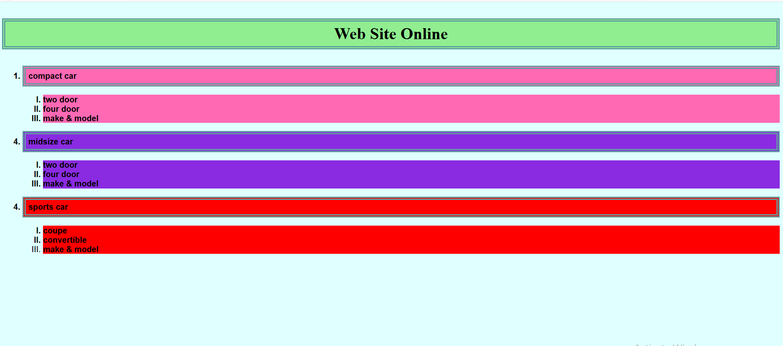

1. (Use external level Style sheet)

Design a multiple webpages including html & CSS. Include all the CSS properties of text , border font etc. The following navigation tabs must be added:

1. Home ( Give info about what your website is about)
2. Information (Include the detailed information related to the particular technology)
3. Gallery (Include images and Videos of technology)
4. About (Give the information about your self)

**SOURCE CODE**

<!doctype html>

<html>

<head>

<meta charset="utf-8">

<title>LAb5task2</title>

<link type="text/css" href="about.css" rel="stylesheet" />

</head>

<style type="text/css">

h1{background-color:burlywood;font-family: Baskerville, "Palatino Linotype", Palatino, "Century Schoolbook L", "Times New Roman", "serif"; text-transform:uppercase; text-align: center;font-weight:200px}

ul{

list-style: none}

.menubar ul li{

background:#3AF846; font-size: 24px;float:right;border:thick;height: 50px; width: 190px;border:1px solid green;line-height: 58px;font-size: right;text-align: center;color: antiquewhite;text-transform: uppercase;

}

.menubar ul li:hover{ background-color:aliceblue; color: antiquewhite;float: right

}

.mainhd{color: lightgreen;font-size: 30px}

</style>

<body>

<h1>Green for lives</h1>

<div class="menubar">

<ul>

<li><a href="hme.html">Home</a></li>

<li><a href="inf.html">Information</a></li>

<li><a href="gall.html">Gallery</a></li>

<li><a href="abt.html">About</a></li>

</ul>

</div>

</body>

</html>

**EXTERNAL SHEET CODE**

body{background-image: url("file:///C:/Users/Lenovo/Downloads/bridge-53769_1280.jpg");background-repeat:no-repeat;background-size: cover}

p{"background-color: aqua; font-family: Cambria, 'Hoefler Text', 'Liberation Serif', Times, 'Times New Roman', 'serif'"; align="center";text-shadow: 5px 5px 9px black;text-align: right; text-transform:"capitalize"}

**OUTPUT**

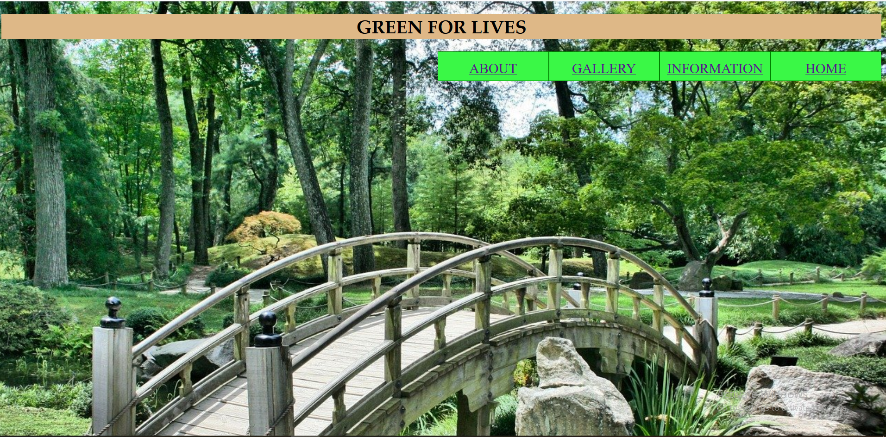

**ABOUT PAGE CODE**

<!doctype html>

<html>

<head>

<meta charset="utf-8">

<title>Untitled Document</title>

</head>

<style>

body{background-color: bisque;}

{

background-color: antiquewhite;font-family: Cambria, "Hoefler Text", "Liberation Serif", Times, "Times New Roman", "serif";margin: 5px;padding: 5px;

}

h1{background-color:burlywood;font-family: Baskerville, "Palatino Linotype", Palatino, "Century Schoolbook L", "Times New Roman", "serif"; text-transform:uppercase; text-align: center;font-size:30px;border: thick;border-color:cadetblue;border-style: double}

p{background-color:lightgreen; font-family: Cambria, 'Hoefler Text', 'Liberation Serif', Times, 'Times New Roman', 'serif'; text-align: center;text-

shadow: 2px 2px 9px black; text-transform:uppercase;font-size: 30px}

</style>

<body>

<h1>About the company</h1>

<p> I am a CEO of "Green of Lives" Company. This Company is made in 1996. We can also Export Plants,Flowers and Seeds.</p>

</body>

</html>

**OUTPUT**

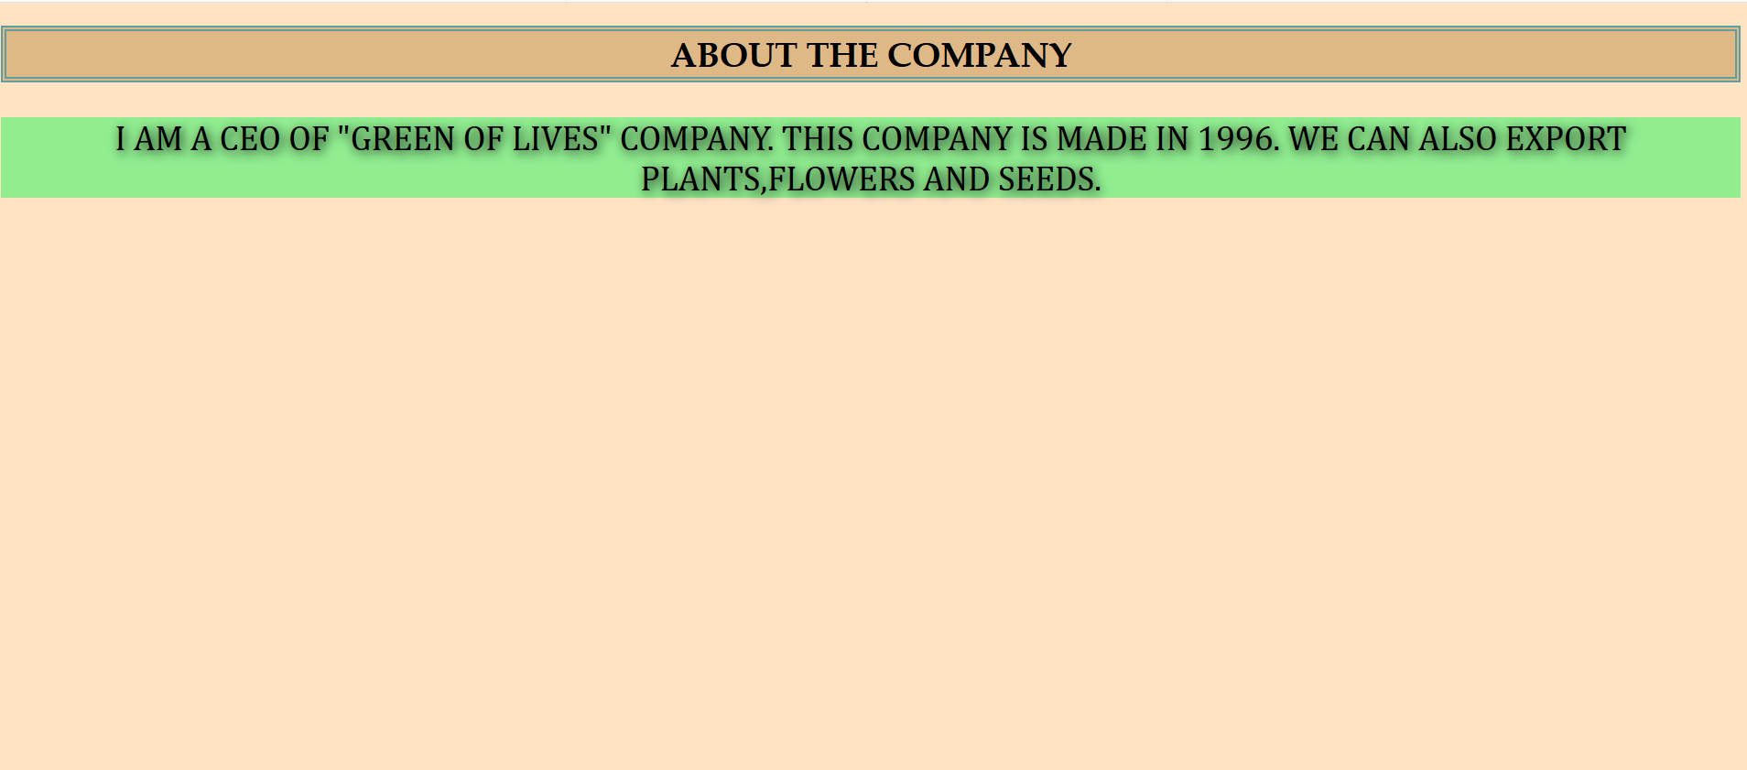

**GALLERY PAGE CODE**

<!doctype html>

<html>

<head>

<meta charset="utf-8">

<title>Untitled Document</title>

</head>

<style>

body{background-color:darkgreen}

h1{background-color:cadetblue;font-family: Cambria, "Hoefler Text", "Liberation Serif", Times, "Times New Roman", "serif"; text-align: center;text-transform:uppercase;border-color: chocolate;border: double;border-width:medium}

</style>

<body>

<h1>images for our services</h1>

<img src="file:///C|/Users/Lenovo/Downloads/garden-2040714_1920.jpg" width="1520" height="210" alt=""/>

<img src="file:///C:/Users/Lenovo/Downloads/rice-plantation-1822444_1920.jpg" width="1520" height="220" alt=""/>

<img src="file:///C:/Users/Lenovo/Downloads/art-gallery-245251_1920.jpg"width="1520" height="215" alt=""/>

</body>

</html>

**OUTPUT**

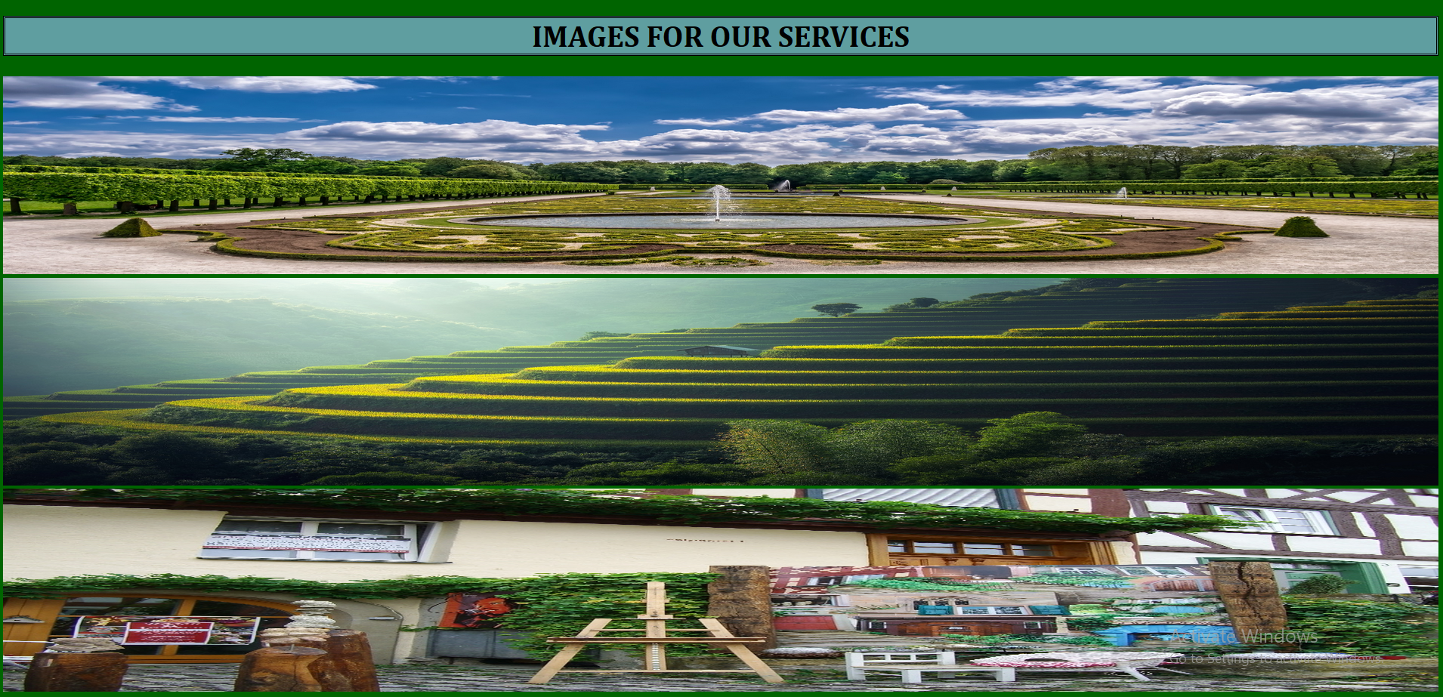

**INFORMATION PAGE CODE**

**SOURCE CODE**

<!doctype html>

<html>

<head>

<meta charset="utf-8">

<title>Untitled Document</title>

</head>

<style>

body{background-color:lightseagreen}

h1{background-color:cadetblue;font-family: Cambria, "Hoefler Text", "Liberation Serif", Times, "Times New Roman", "serif"; text-align: center;text-transform:uppercase;border-color: chocolate;border: double;border-width:medium}

ul{

list-style: none;}

.menubar ul li{

background:#3AF846; font-size: 24px;float:right;text-align: center;border:thick;height: 40px; width: 220px;border:1px solid green;line-height: 40px;font-size: right;text-align: center;color:darkcyan;font-weight: 200px;font-family: Baskerville, "Palatino Linotype", Palatino, "Century Schoolbook L", "Times New Roman", "serif"

}

</style>

<body>

<h1>Information</h1>

<div class="menubar">

<ul>

<li>Company Address</li>

<li>Fax</li>

<li>Telephone Number</li>

<li>Email</li>

</ul>

</div>

</body>

</html>

**OUTPUT**

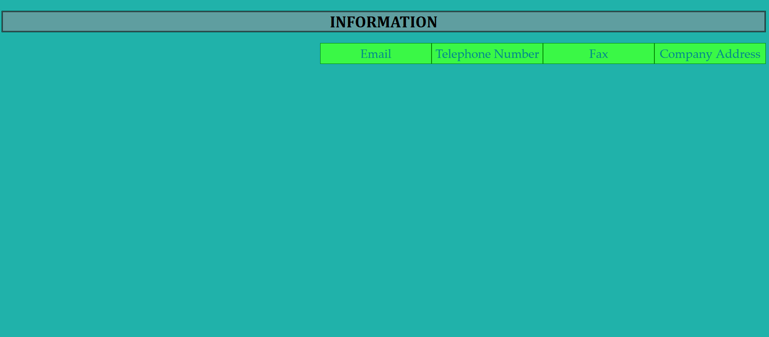

**HOME PAGE CODE**

<!doctype html>

<html>

<head>

<meta charset="utf-8">

<title>Untitled Document</title>

</head>

<style>

body{background-image: url("home.PNG");background-repeat:no-repeat;background-size: cover}

h1{background-color:cadetblue;font-family: Cambria, "Hoefler Text", "Liberation Serif", Times, "Times New Roman", "serif"; text-align: center;text-transform:uppercase;border-color: chocolate;border: double;border-width:medium}

h3{background-color:cadetblue;font-family: Cambria, "Hoefler Text", "Liberation Serif", Times, "Times New Roman", "serif"; text-align: center;border-color: chocolate;border: double;border-width:medium}

</style>

<body>

<h1>Company services</h1>

<h3>Our Company give services for Lawns,Gardens and Orchids decoration. All types of Flowers,Plants and Seeds are also availabel and our effort is that our customer feel reliable for our good services</h3>

</body>

</html>

**OUTPUT**

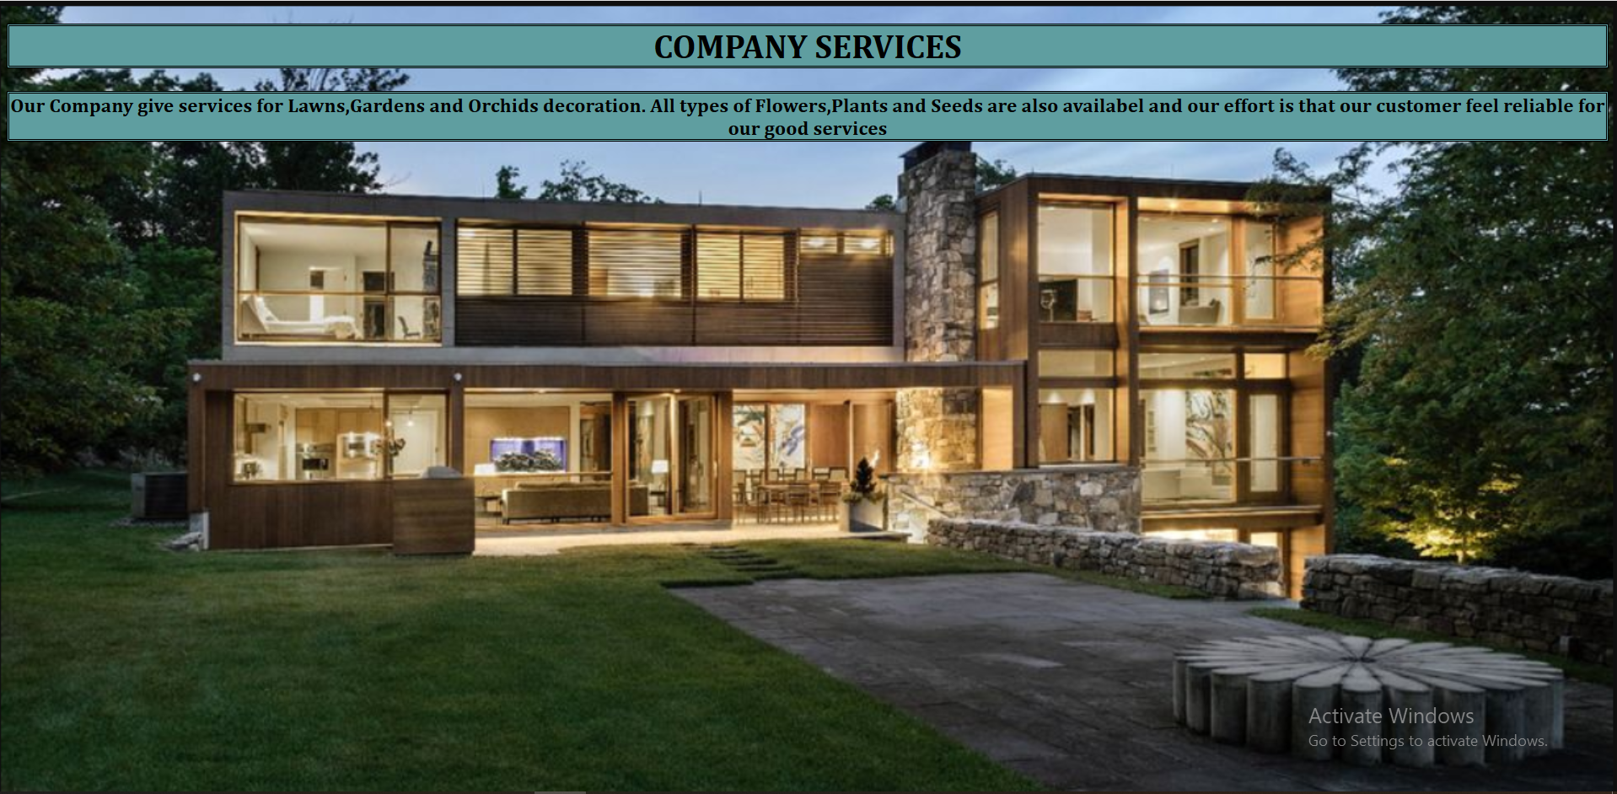

1. Apply CSS to sign in and Login page you design in previous lab. Using document level style sheet (Internal Style Sheet).

**SOURCE CODE**

<!doctype html>

<html>

<head>

<meta charset="utf-8">

<title>MY WEB PAGE</title>

<style>

body{background-image: url("file:///C:/Users/Lenovo/Downloads/sidepage.png");background-position: center; background-repeat: no-repeat;background-attachment: fixed;background-size: cover}

body{

background-color: hotpink; background-position: center;font-family: Cambria, "Hoefler Text", "Liberation Serif", Times, "Times New Roman", "serif"; alignment-baseline: center

}

</style>

</head>

<body>

<center><h1>Welcome To Our Website</h1></center>

<center><img src="file:///C:/Users/Lenovo/Downloads/log.png" width = "170" height = "170" alt=""/></center>

<br>

<center><label><b>Username</label>

<input type = "text" placeholder="Enter UserName"></center>

<br>

<center><label>Password</label>

<input type = "text" placeholder="Enter Password"></center>

<br>

<center><input type="button" value="Login">

<input type = "button" value="Cancel"></center>

<br>

<center><input type="checkbox">

<label>Remember me</label></center>

<center><label>Forgot <a href=>password?</a></label></center></b>

<center><h1> </h1></center>

<center><img src="file:///C:/Users/Lenovo/Downloads/wel.PNG" width = "700" height = "270" alt=""/></center>

</body>

</html>

**OUTPUT**

